Stocks and flows

* Stocks are static variables and flows are dynamic variables.
  + Land:
  + Labor:
  + Capital:
  + Entrepreneurship:

What, How, For Whom?

* What -> Consumers are king: **what** is produced is determined by the consumer.
* How -> Resource market: is the **how.**
* Whom -> Labor market: is the **whom**.

Specialization:

* Two components of the specialization:
  + Economic agent
  + Firms

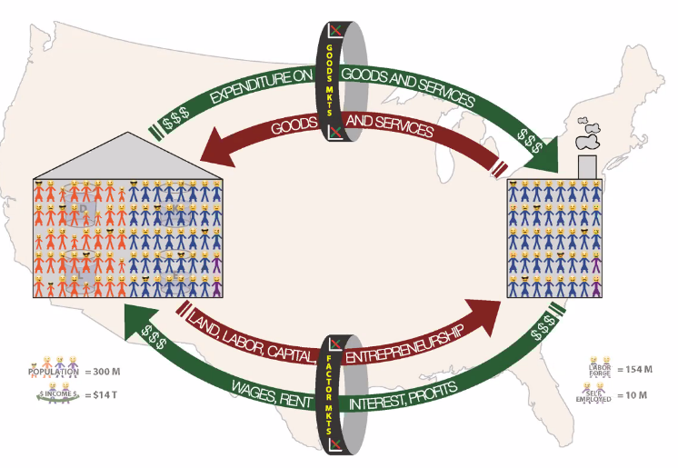The free market:

* The resources in the economy reside with the individual. Even corporations.
* Good markets: Walmart is supplying the market and people are demanding (micro).
* Factor markets: Walmart demands labor and people offer their labor.
* Example: Soda was made of several resources, which can be mapped by income made by somebody else.

Enter the government:

* 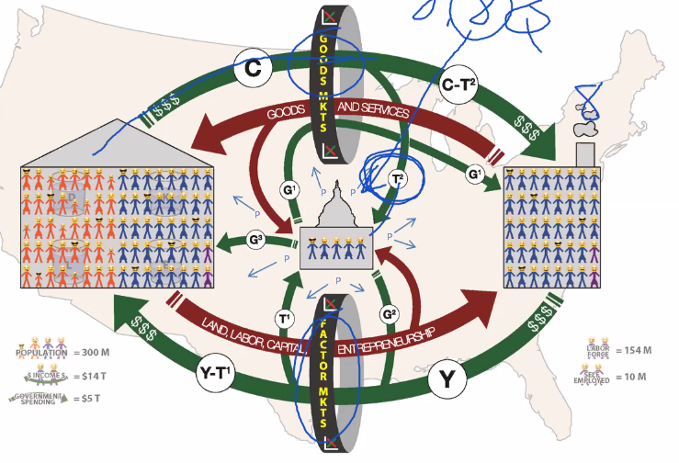We need a government; we need a limited government; it is when government gets too big when the problem starts.
* Government demands public goods: not everything government demands are public goods, public goods are non-excludable (hard for people not to pay, taxes) and non-rival.
* Government takes a part to divert and maintain itself.
* Government makes some Robin Hood spending, example: take from the healthy and give to the sick, take from the employed and give to the unemployed, taking from one person by tax by force and giving that which was taken and give it to another person. The government takes an income tax and takes a sales tax, then the government does some government stuff.
* Interesting: Guatemala, Chile and Panama are in the top quartile of economic freedom, South America usually demand a more authoritarian approach.

Enter the rest of the world:

* How money is leaving and entering the country,
* Foreign exchange is necessary for exchange in currency.

What is economic freedom?

* When the property they acquire without force, fraud or theft is protected from physical invasion by others and they are free to use, exchange, or give their property as long as their actions do not violate the identical rights of others. (Do what you want but do not hurt other people).